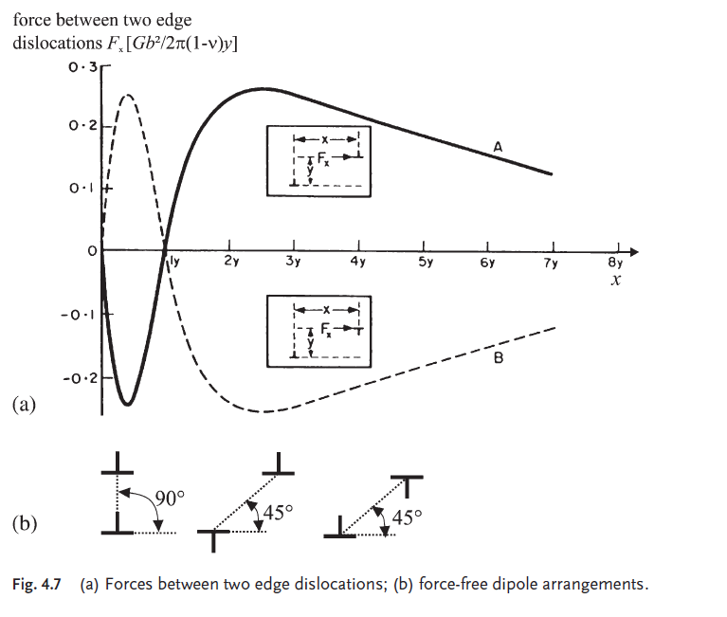
Figure 1 Buch Krupp (2007) S.84

Figure 2 Buch Krupp S.100 - Development of fatigue damage in polycrystalline metals and alloys

